Roll No.: 16010121200

Experiment / assignment / tutorial No.: 08

TITLE : Data Analytics in Healthcare

AIM: perform data analytics on healthcare data (ECG dataset)
___________________________________________________
Expected Outcome of Experiment:
___________________________________________________________________
Books/ Journals/ Websites referred:
https://matplotlib.org/stable/tutorials/pyplot.html
https://vitalflux.com/autoregressive-ar-models-with-python-examples/
____________________________________________________________________

Dataset: http://www.timeseriesclassification.com/description.php?Dataset=ECG5000

Language: C/C++/Java/Python/other – Choice of student

Steps: 1. Download ECG dataset (Given).
2. Pre-process the dataset if needed.
3. Perform analytics on given dataset
4. Display result/ Visualize

List various algorithm used to perform analytics:
ARIMA and AR model have been used in this experiment

Implementation
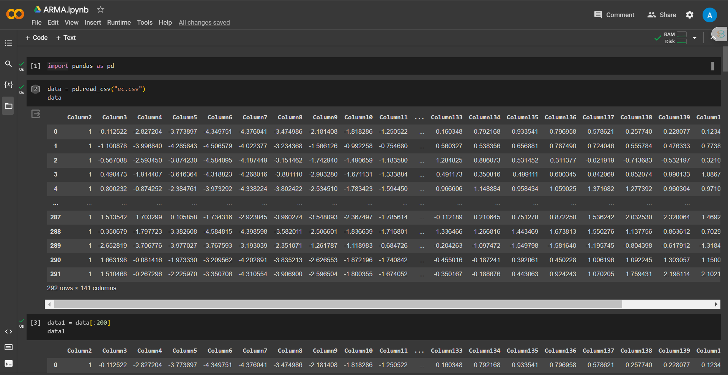
Visualization for all the graphs:
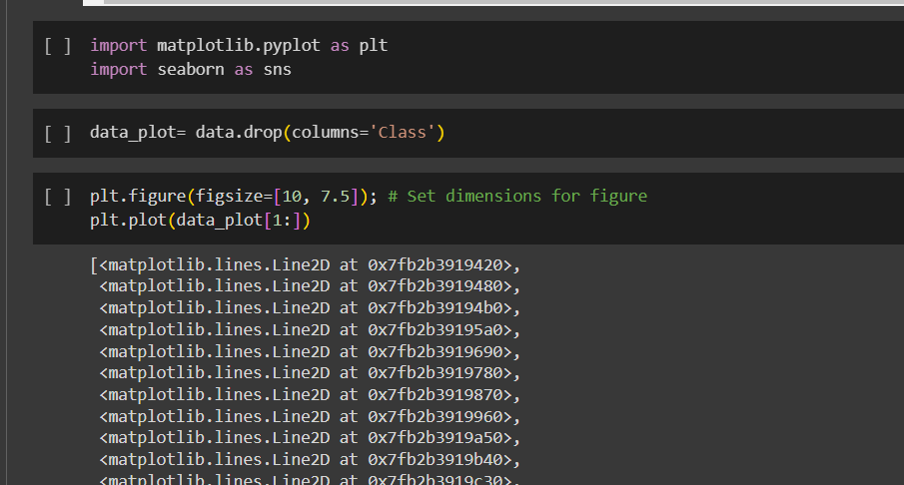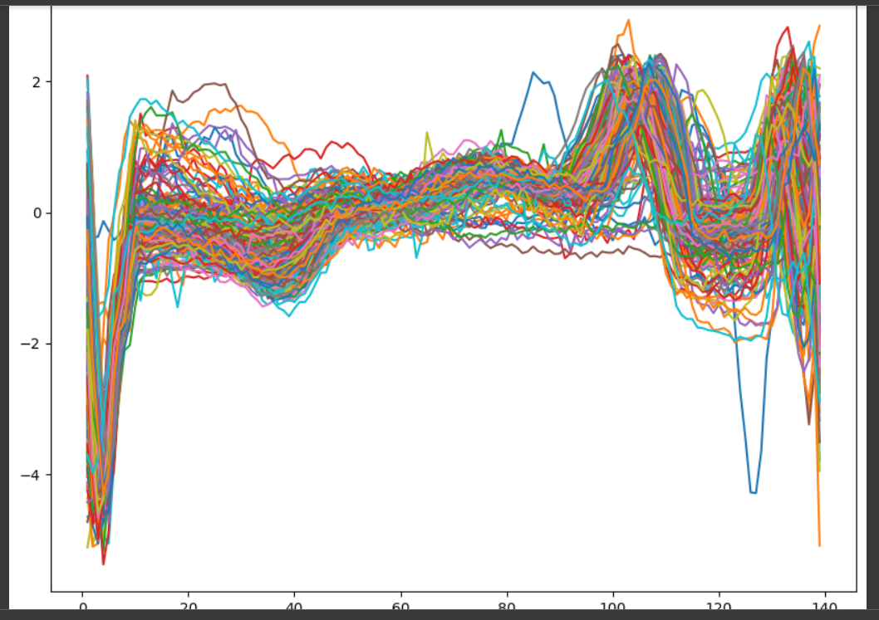
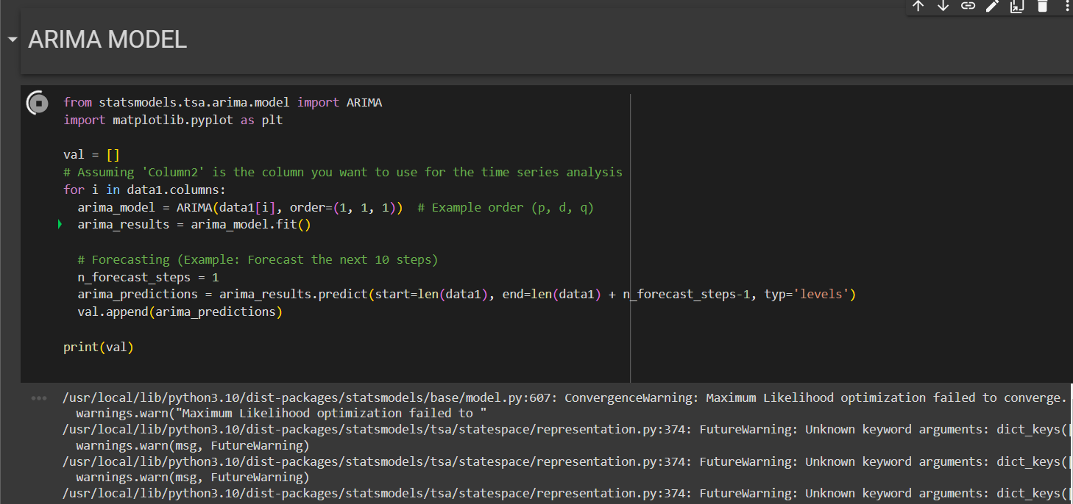
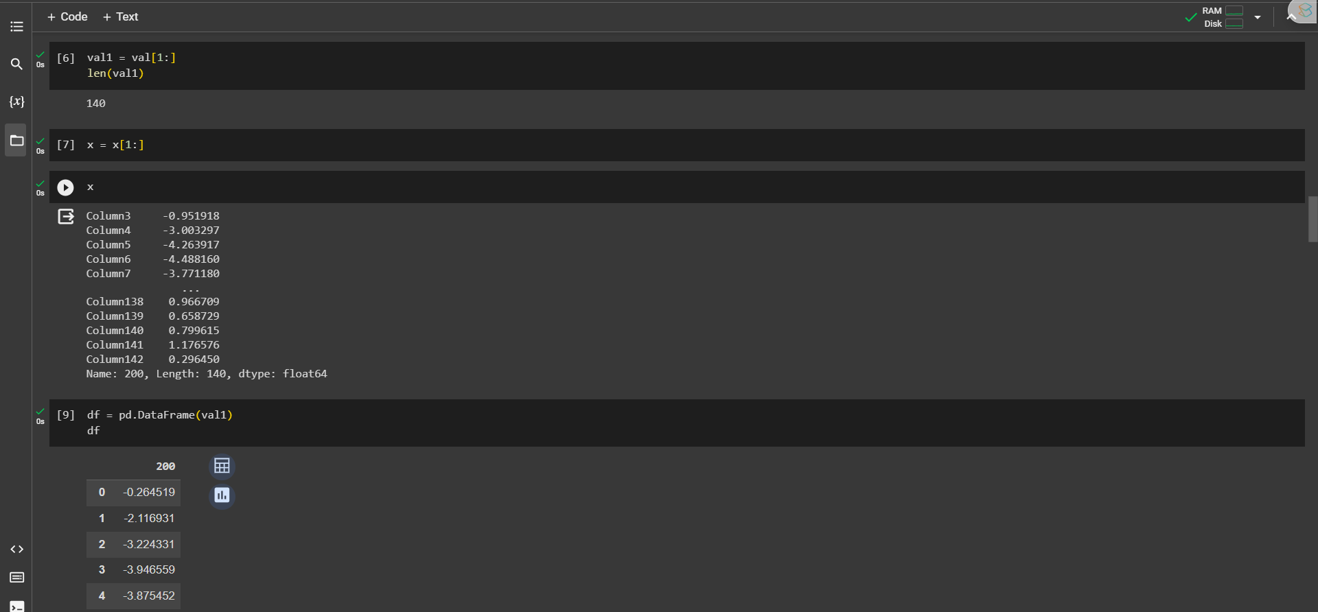
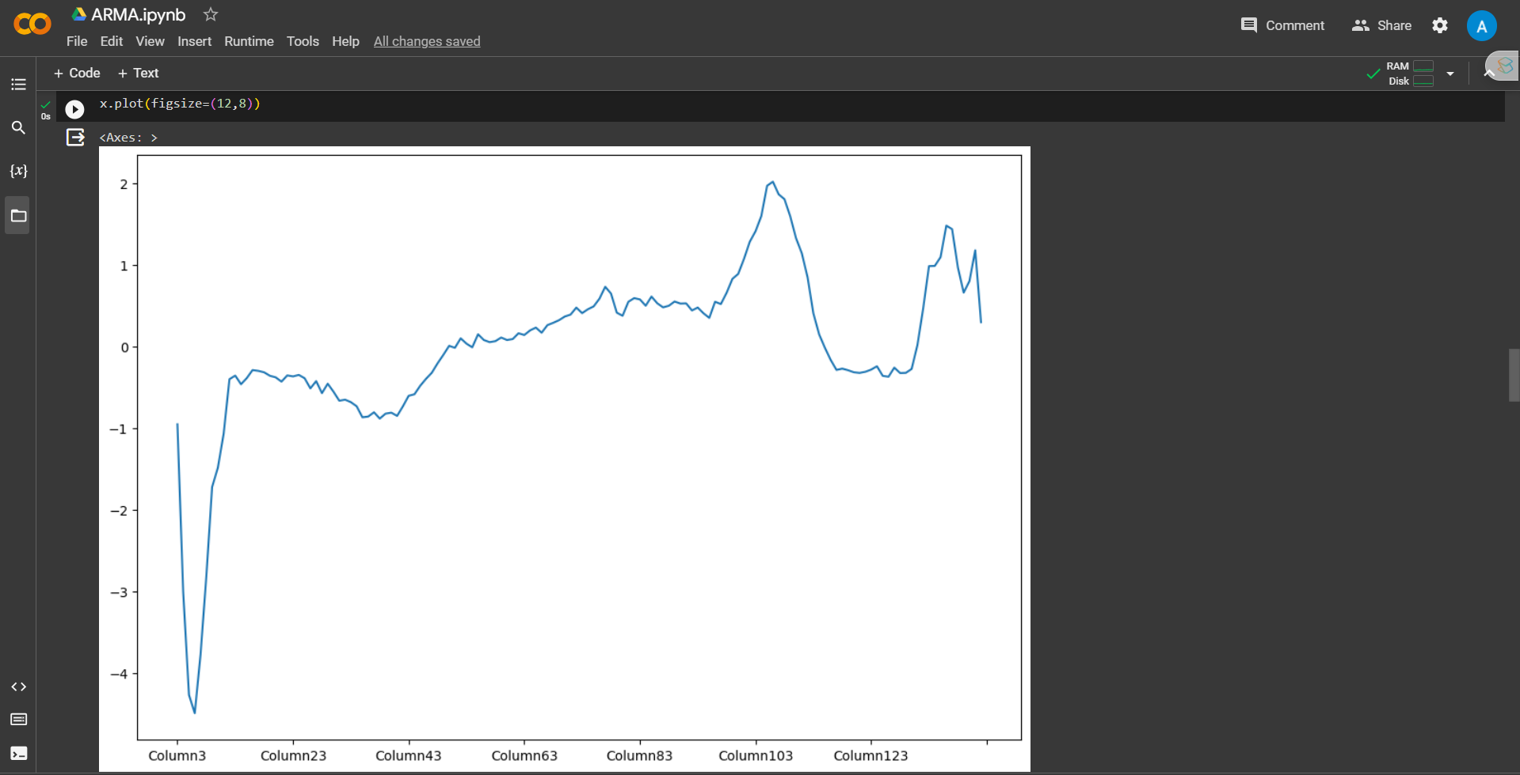
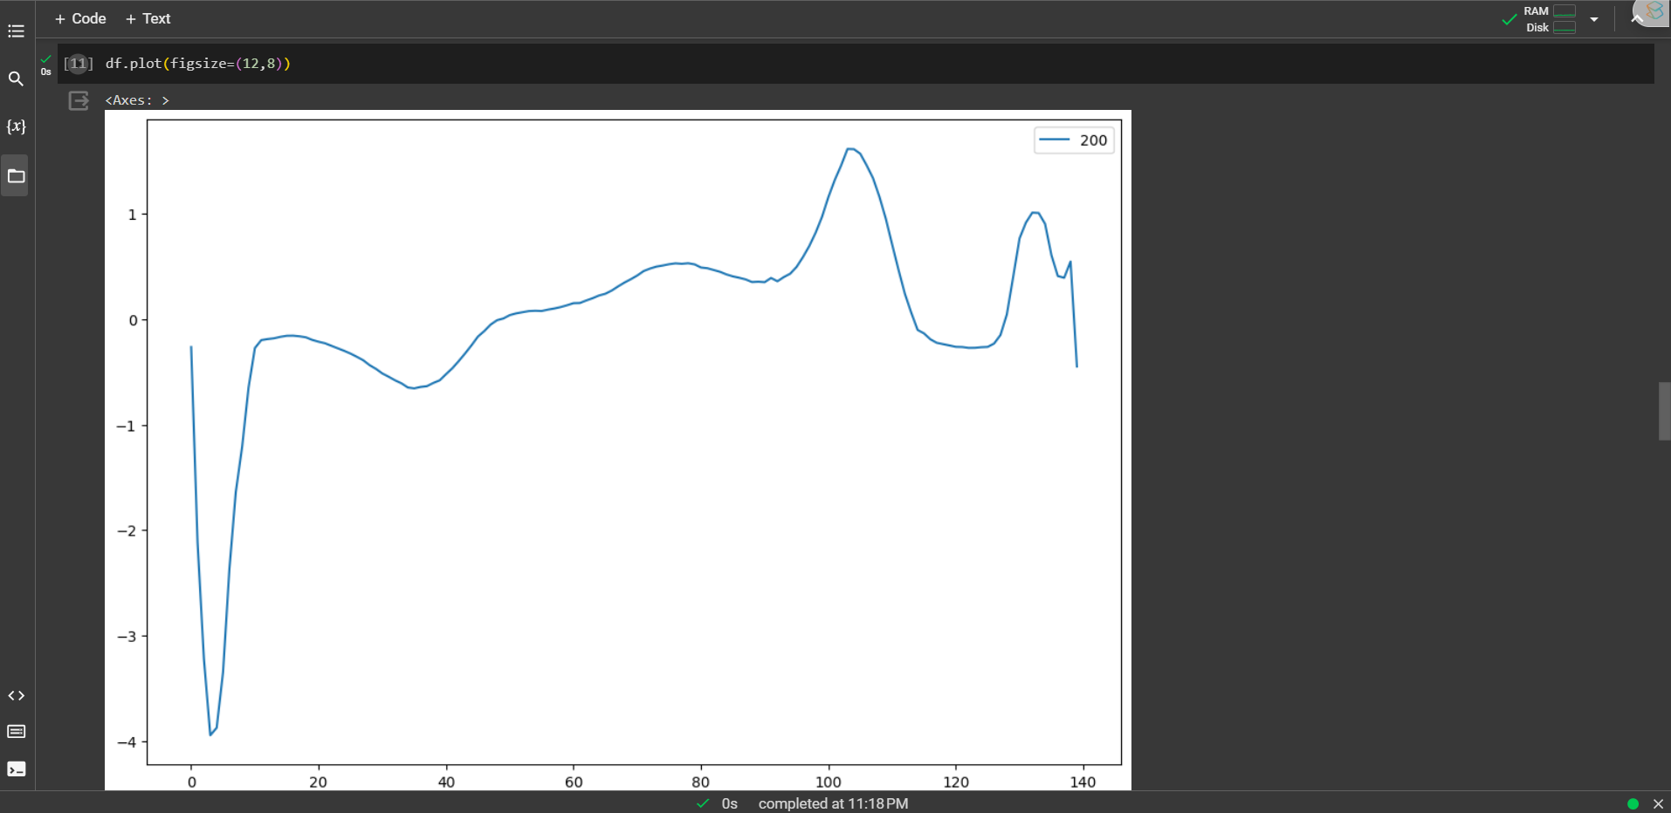
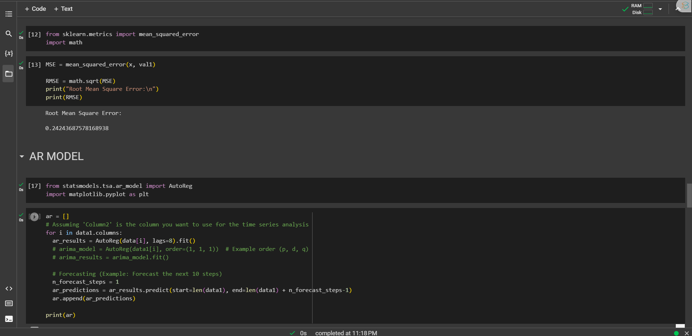
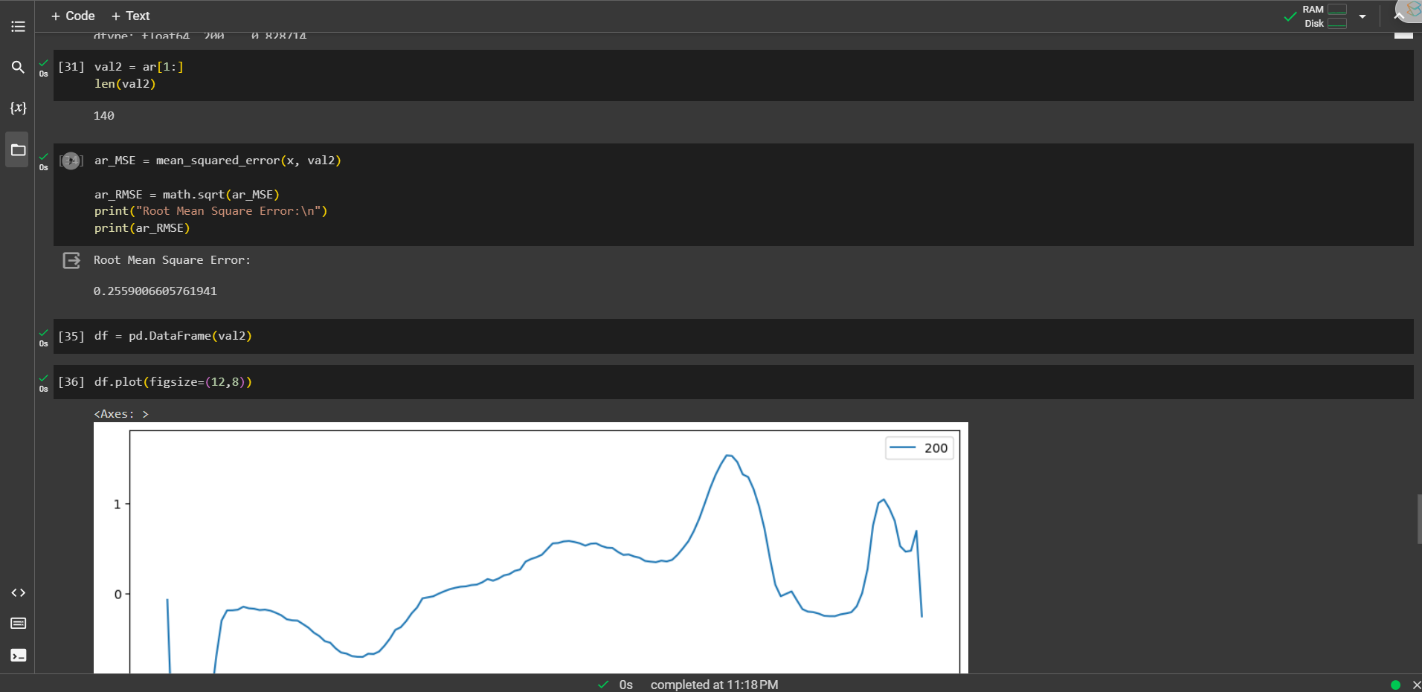
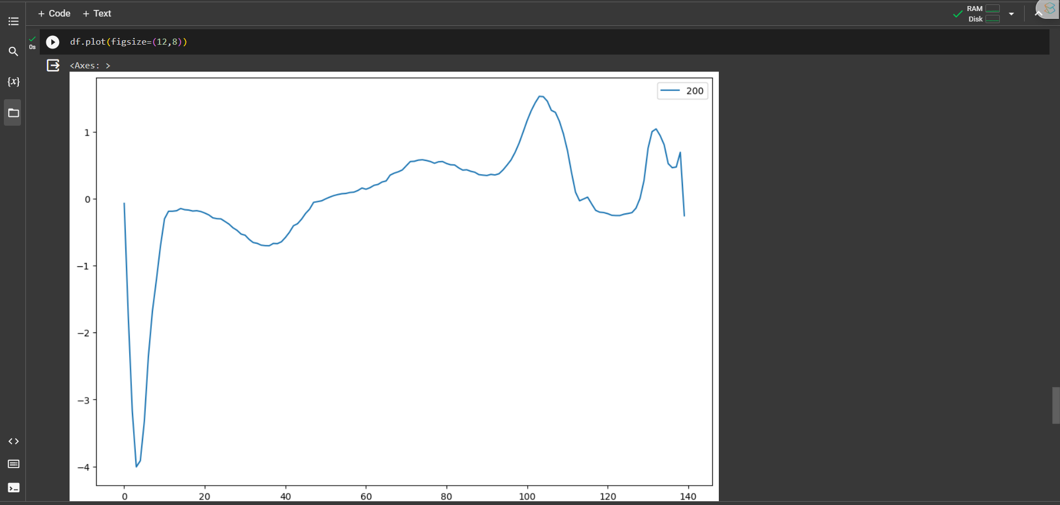
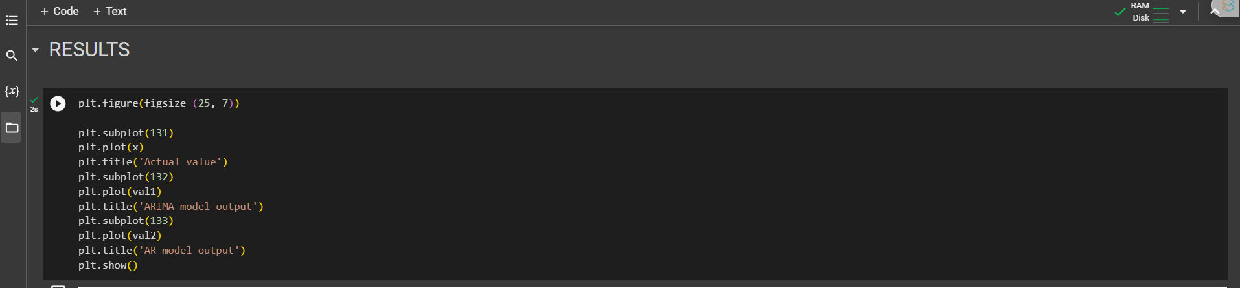
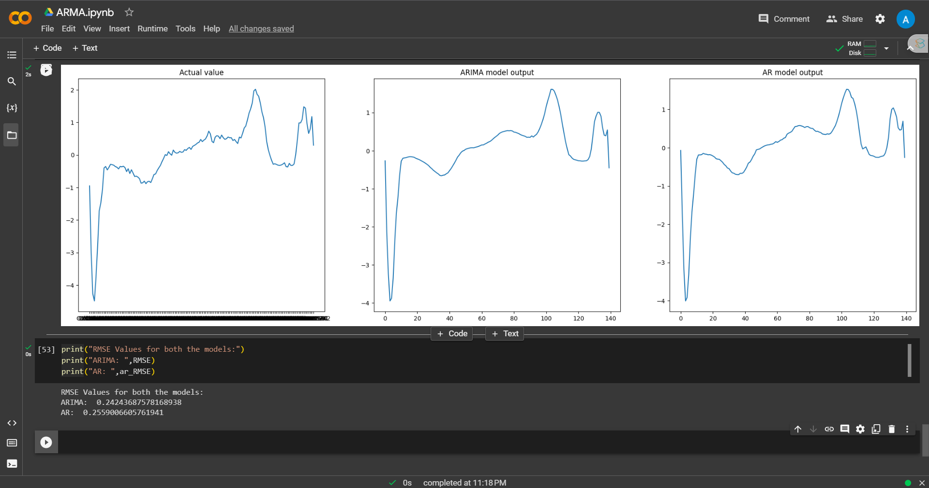

Code link:
https://colab.research.google.com/drive/1Bn8XAutHhf7E5JXtdLOSuVLdW1UFA2na?usp=sharing

Conclusion (Interpretation of result):

ARIMA and AR model have been used on the dataset and ARIMA performs better than AR as seen from the results. (errors have also been calculated in the code)

